Coursework EE401: Advanced Comm. Theory

Part-B

“Localisation of Wireless Signals”

**Task-1: Time-based Localisation**

For Task-1, the time of arrival at each receiver is firstly estimated according the power of received signal.

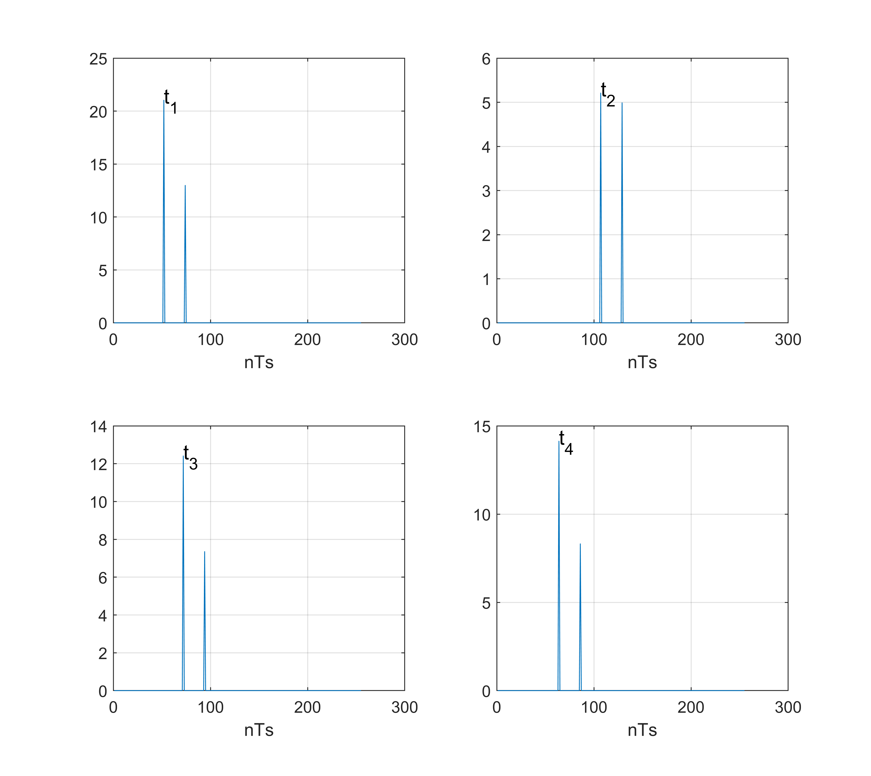

Figure 1 Time of arrival at each receiver

According the Figure, the time of arrival at the four receivers are 52Ts, 107Ts, 72Ts, and 64Ts respectively.

* ***Time of Arrival (TOA) Localisation***

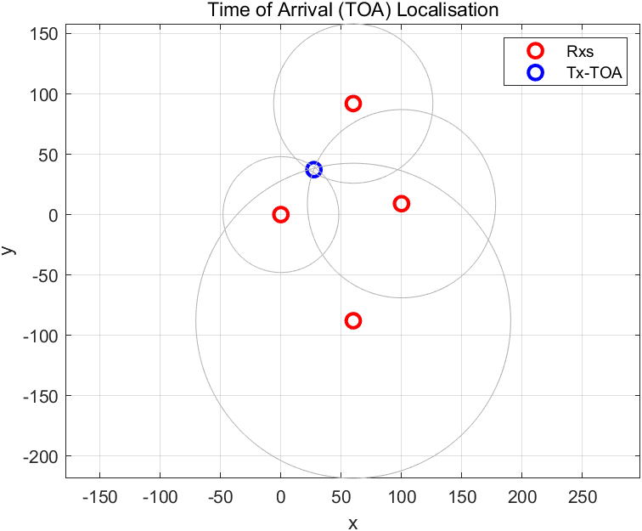

Figure 2 TOA Localisation

The Figure 2 shows the localization result, which is *(27.4127, 37.2322)*. The location of the Tx is determined by the distance from the four Rx, which are indicates by the circles in the figure.

* ***Time Difference of Arrival (TDOA) Localisation***

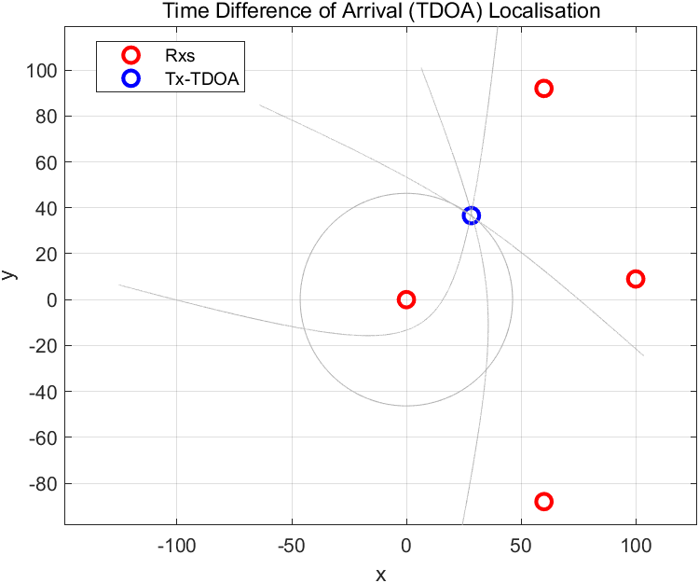

Figure 3 TDOA Localisation

The Figure 3 shows the localization result, which is *(28.3456, 36.6107)*. The distance of between the Tx and the first Rx can be estimated, which is indicated by the circle in the figure. The differences between the distance from Tx to the first Rx and other Rxs can be calculated, which are indicated by the hyperbolas in the figures. The location of the Tx is determined by the intersection place of the circle and hyperbolas.

**Task-2: Received Signal Strength (RSS) Localisation**

In this method, the distance between Tx and each Rx is estimated based on the power of the received signal. Once the distances are estimated, the location of the Tx can be determined.

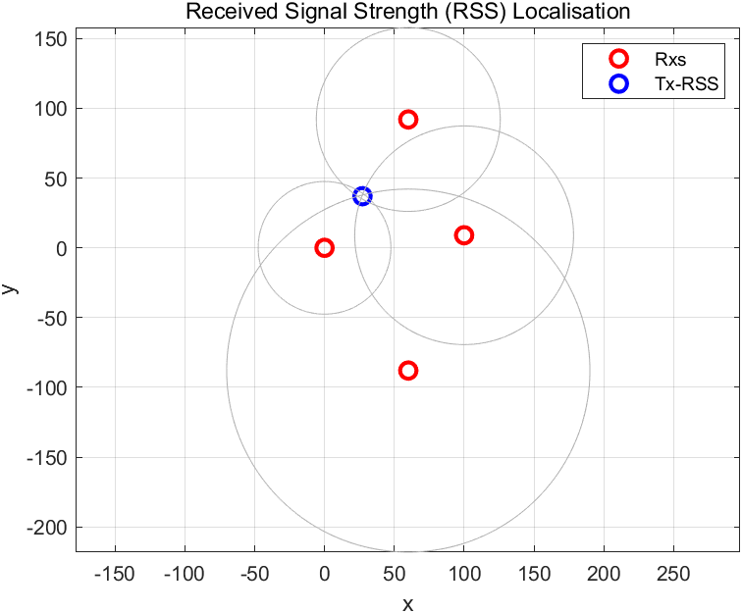

Figure 4 RSS Localisation

The Figure 4 shows the localization result, which is *(27.1879, 36.9807)*. The location of the Tx is determined by the distance from the four Rx, which are indicates by the circles in the figure.

**Task-3: Direction of Arrival (DOA) Localisation**

In this method, the directions of arrival at each Rx are firstly estimated using the MUSIC cost function.

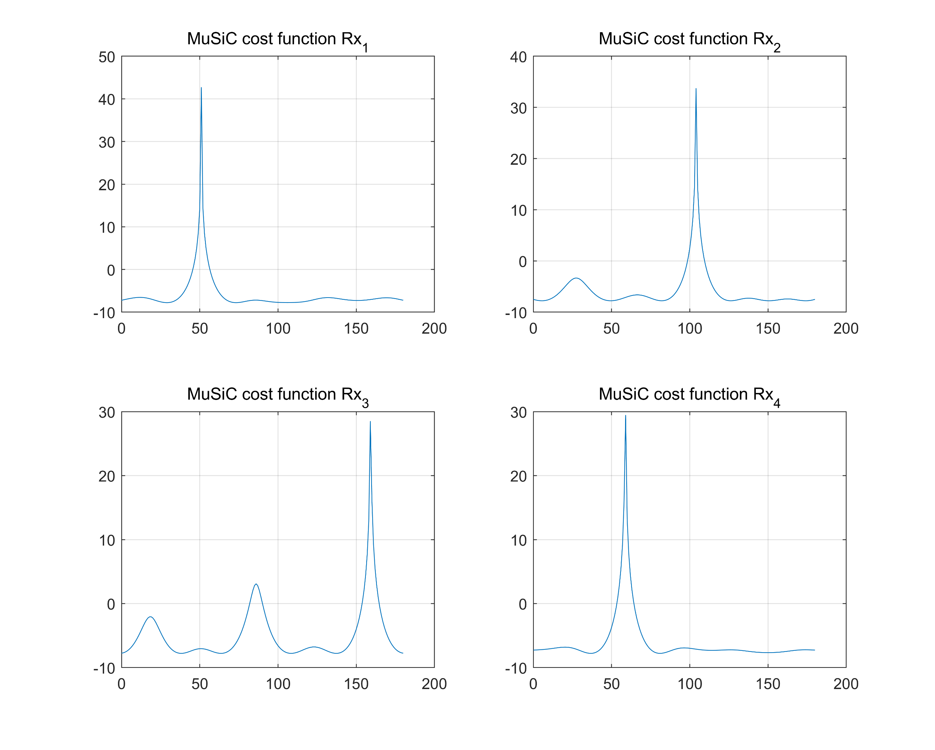

Figure 5 Estimation of DOAs

According to the results in the Figure 5, the DOAs at each Rx are [52, 0], [105, 0], [160, 0], and [60, 0].

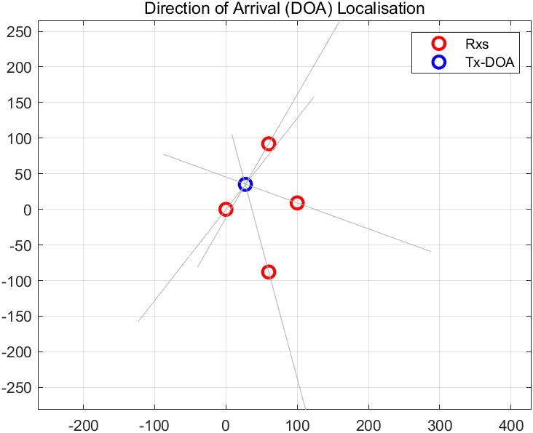

Figure 6 DOA Localisation

The localisation result is shown in Figure 6, which is *(27.2333, 35.0775)*. The location of Tx is determined by the DOA at each Rx, and the DOAs are indicated by the straight line in the figure.

**Task-4: Large Aperture Array Localisation**

In this method, the four receivers are considered jointly as a large aperture array. Based the received signals with different reference points of the large aperture array, the location of Tx can be estimated.

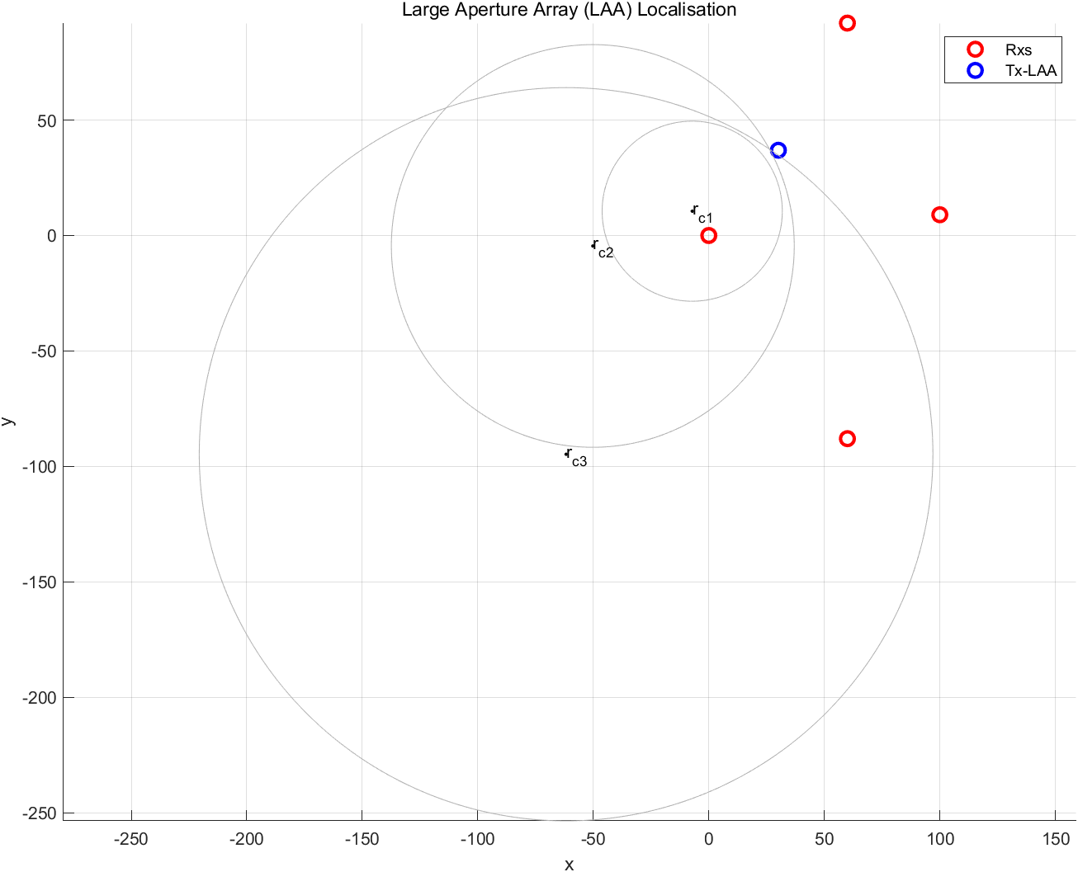

Figure 7 LAA Localisation

In LAA localisation method, the location of Tx is determined by the intersection place of several newly defined circular loci in literature [1]. The $r_{c1}$, $r_{c2}$, and $r_{c3}$ are the centers of the three circular loci in Figure 7. The location of Tx is Figure 7 is *(30.1227,36.9309).*

**Reference**

1. A. Manikas, Y. I. Kamil and M. Willerton, "Source Localization Using Sparse Large Aperture Arrays," in IEEE Transactions on Signal Processing, vol. 60, no. 12, pp. 6617-6629, Dec. 2012, doi: 10.1109/TSP.2012.2210886.